TESTSTAND EQMETER NEW SEQUENCES

# CommonUtilitySequencesEqRed

## Init_selected_generator

Initialize the power supply for the test.

1. Omicron: initialize the communication and the configuration of Voltages and Currents.
2. Zera: initialize the communication and the meter constant (Number of Pulses of the LED)
3. Production Port

## Dispose_selected_generator

Dispose the power supply used during the test and shut down every output.

1. Omicron
2. Zera
3. Production Port

## Power_ON_generator

Imports a container of Source Values and applies it to the power supply (See NOTATION).

1. Omicron
   1. Inverts the angles because the Omicron angles turn in the opposite way of the EqMeter
   2. Generates voltages and currents taken from the modified Source Values
2. Zera
   1. Inverts the angles because the Zera angles turn in the opposite way of the EqMeter
   2. In case of negative current (Export) the angle is shifted by 180 degrees
   3. In case of D11 the currents and voltages of the phases 2 and 3 need to be different from zero in order to avoid an error in the script that commands the Zera.
   4. Generates voltages and currents taken from the modified Source Values

## Power_OFF_generator

Shut down the Meter. In case of Omicron the currents are still passing.

## Zera_Energy_Accuracy

The duration of the energy accuracy test is fixed (around 30 seconds) and the number of pulses of the LED is set in the sequence Init_selected_generator.

1. Set the frequency
2. Set the measure mode of the accuracy chosen between Active and Reactive energy.
3. Generates voltages and currents and chose between 1 or 3 phases.
4. Get the result from the LED of the meter.

## Omicron_Energy_Accuracy

ATTENTION: differently from Zera_Energy_Accuracy this sequence does not generates the currents and voltages and so it needs the Power_ON_generator sequence if the source values change.

The duration of the energy accuracy test and the number of pulses of the LED can be chosen from the variables of this sequence (the number of pulses needs to match the one set in the meter).

1. Computes the total power expected.
2. Clear and start the counter.
3. Computes the energy error.

## Energy_Accuracy

Computes and returns the error on the Active/Reactive energy measurement.

1. Omicron
   1. Invert the angles
   2. Omicron_Energy_Accuracy
2. Zera
   1. Set the installation type
   2. Inverts the angles
   3. Compute the accuracy with the subsequence Zera_Energy_Accuracy.

## Init PreUUT

1. Initialize and connect with the production port
2. Initialize the meter in order to communicate via DLL
3. Get and display the ProductType, FW Version and SerialNumber of the device.

# Energy Accuracy

Compute the percentage error on the Active/Reactive Import/Export energy measurement.

1. Imports the .csv file with all the test points.
2. Start the real-time monitor with labview which will show the energy error during the test.
3. Executes a stream loop on every test point.
   1. Set the Source value of the power supply from the .csv test point.
   2. Compute the expect results with the selected configuration.
   3. Energy_Accuracy with the actual source values.
   4. Test on the energy measurement with respect to the expected result.
   5. Writes the output.csv and the real-time monitor.
4. Display the graph with all the test points.

# Energy Register Power Fail

Check that the energy registers (Modbus) are saved after a power fail and only right ones are increased.

1. Active Import energy
   1. Power_ON_generator with only voltages
   2. Read energy registers at power ON (skip the ones not implemented)
   3. Power_ON_generator with Power Factor 1 and import currents.
   4. Read energy register before power fail
   5. Power Fail
   6. Power_ON_generator with only voltages
   7. Read energy registers after power fail
   8. Numeric test on all the energy registers (skip the ones not implemented)
2. Active Export energy
3. Reactive Import energy
4. Reactive Export energy

# Repeated Power Fail

Check that the Active energy register is saved after a power fail and is updated by the right amount. Check that the Active energy register is not saved in the flash if the power fail occurs before 8 seconds after power ON. Check that the Active energy register is saved in the flash if the power fail occurs after 8 seconds after power ON. Test the stability of the flash writing process by performing a power fail every 8 seconds for several times. Test the stability of the flash writing process by performing a power fail with random time delays. Optimized with the Omicron.

# Frequency/Voltage Variation

Tests the energy measurement accuracy at minimum and maximum frequency/voltage.

1. Imports the .csv file with all the test points.
2. Asks for the number of test points at PF=1 and PF=0.5 in order to realize the graphs
3. Start the real-time monitor with labview which will show the energy error during the test.
4. Executes a stream loop on every test point
   1. Clean the real-time graph if there is a change in the PF
   2. Set the Source value of the power supply from the .csv test point.
   3. Compute the expect results with the selected configuration.
   4. Energy_Accuracy with the actual source values.
   5. Test on the energy measurement with respect to the expected result.
   6. Writes the output.csv and the real-time monitor.
   7. Build the correct graph.

# Instantaneous Values

1. Asks for the quantity that is varying in the .csv file.
2. Imports the .csv file with all the test points.
3. Executes a stream loop on every test point.
   1. Set the Source value of the power supply from the .csv test point.
   2. Compute the expect results with the selected configuration.
   3. Read via DLL 5 times the values of the instant quantities.
   4. Compute the averages and the errors.
4. Display the graph with the x axes on the varying quantity.

# Modbus RTU Settings

Tests the Modbus communication at each address, parity and baudrate.

1. Test the Modbus communication at all addresses
2. Imports the .csv file with all the combinations of baudrate and parity.
3. Executes a stream loop on every test point

# Realtime Sampling

Collects the instantaneous values of Voltages, Currents and Powers without perform an average.

1. Imports the .csv file with all the test points.
2. Read the values for “Locals.Sampling_iterations” times every “Locals.Sampling_wait” seconds.
3. Display the graphs with the time on the orizontal scale.

# Repeatability_new

Tests that the energy measurement does not shift too much in time.

1. Import the .csv file with the test points.
2. Execute a stream loop on the test points.
   1. Start real-time monitor at each cycle.
   2. Compute expected results.
   3. Power_ON_generator at the current source values
   4. Wait for an initial amount of time
   5. Loop of Energy_Accuracy measurements in order to tests the shift of the accuracy with respect to the first one.

# Self-Heating

Tests the accuracy of the energy measurement in conditions of heating the wires by applying maximum current for long time.

1. Power ON the meter at nominal voltage for 60 minutes.
2. Apply maximum currents
3. Check every 2 minutes the Energy_Accuracy for 60 minutes.

# CommonUtilityHmiIPSES

# Input ON OFF

# Input pulse

# Output Alarm

# Output Communication

# Output ON OFF

# Output Pulse

# NOTATION

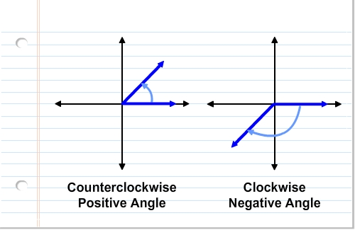The angles turn Counterclockwise.

The voltages angles are ALWAYS FIXED to: $φ_{V1}=0, { φ}_{V2}=-120,{ φ}_{V3}=120$.

The currents angles are positive when the sinusoid of the current is in advance with respect to the one of the voltage (for example: $φ_{V1}=0$ and $φ_{I1}=30$ at the start time the current is already high while the voltage is 0).

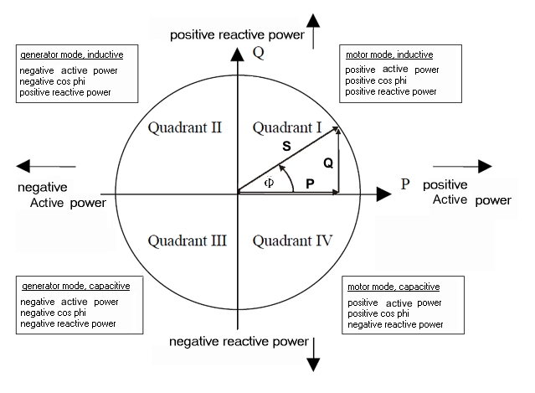Phase displacement angle is : $Φ= φ_{Vi}- φ_{Ii}$

Power Factor: $PF=\cos{Φ}$

Power Factor Reactive : ${PF}_{Reactive}= \sin{Φ}$

Active Power: $P_{Act}=V*I*cos⁡(φ_{Vi}- φ_{Ii})$

Reactive Power: $P_{React}=V*I*sin⁡(φ_{Vi}- φ_{Ii})$

Apparent Power: $P_{App}=V*I$

For Export currents, the easiest way is to shift the currents angles by 180°.

The key point is that, if the angles of the currents are positive (turn counterclockwise), the Phase displacement angle $Φ$ becomes negative (like turn clockwise).

Motor mode = Import and Generator mode = Export (referred to the Active power)

So, if I want to reproduce a Capacitive Load at power factor 0.5 I need to set the current angles to $φ_{I1}=60, { φ}_{I2}=-60,{ φ}_{I3}=180$ in order to reach the 4° quadrant with $Φ= -60$.

GROWTH OF ENERGY REGISTERS

|  |  |  |  |  |  |
| --- | --- | --- | --- | --- | --- |
| $$φ_{I}$$ | $$Φ=(φ_{V}-φ_{I})$$ | ACTIVE IMPORT | ACTIVE EXPORT | REACTIVE IMPORT | REACTIVE EXPORT |
| 0° | **0°** | **↑** | **X** | **X** | **X** |
| 45° | **-45°** | **↑** | **X** | **X** | **↑** |
| 90° | **-90°** | **X** | **X** | **X** | **↑** |
| 135° | **-135°** | **X** | **↑** | **X** | **↑** |
| 180° | **-180°** | **X** | **↑** | **X** | **X** |
| 225° | **-225°** | **X** | **↑** | **↑** | **X** |
| 270° | **-270°** | **X** | **X** | **↑** | **X** |
| 315° | **-315°** | **↑** | **X** | **↑** | **X** |